World Homeopathy Day, April 10, 2019, Philadelphia, PA, USA by B.Merizalde
One of this year’s celebrations of the World Homeopathy Day, in remembrance of Samuel Hahnemann’s birthday, took place in Philadelphia, which is, ostensibly, a cradle of homeopathy since the middle of the 19th century, with the advent of Constantin Hering, Adolph Lippe, Henry N Guernsey, Ernest Farrington, James T Kent, and others, who have influenced the practice of homeopathy by providing clear and well documented cases to prove the efficacy of homeopathic medicine even in critical conditions, in hundreds of patients.
We had the pleasure to host Dr. Renzo Galassi, immediate past president of the LMHI, Dr. Gustavo Cataldi, LMHI vice-president, and Dr. Altunay Agaoglu, LMHI secretary general, who came to the United States, from opposite parts of the world, for a pilgrimage to visit the historical places associated with homeopathy, in the North-East and the Mid-West. They are convinced that this volume of the history of homeopathy is complementary and enriches the endowment provided by Samuel Hahnemann, the founder of homeopathy.
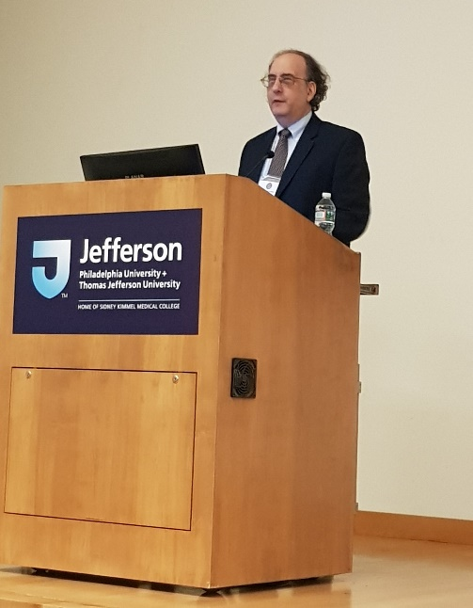
Our event was kicked off by Dr. Ron Dushkin, the American Institute of Homeopathy’s president, with an inspired and inspiring and spirited presentation and performance, reviewing the history of the American Institute of Homeopathy, who celebrated the 175th anniversary. He reminded us that it was called an institute rather than an association, because of its emphasis on education and
Figure 1 Dr Ron Dushkin
The purpose of homeopathy, Dr. Dushkin, reminded us, rephrasing Arethra Franklin’s song is “Freedom,” freedom from suffering for our patients. If we were to have a dinner with someone special, he would invite Hahnemann, Hering, Boenninghausen and Kent; at such a gathering, we could ask them what they would suggest, in unison, after Fleetwood Mac’s hit, “Don’t Stop. Thinking About Tomorrow,” yesterday is gone, and the future will be better. It is easy to get caught up with what we have in hand, and we need to project ourselves into the future. Finally, through an inspiration during meditation, and asking for what words of hope we can have, in the midst of all that that is going on is, in the words of Aretha Franklin “I will Survive,” homeopathy will survive. It has for two centuries and the hard work of people from around the world are giving their time and energy to make it happen.
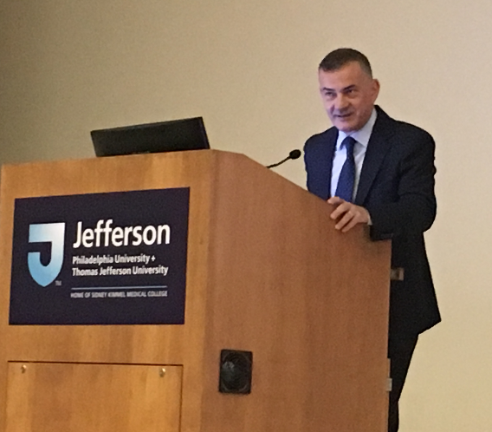
Dr. Galassi provided us with a succinct yet rich review of the history, and current work of the LMHI, as a sponsoring organization of this event, and of other projects in the world to bring homeopathy to the people.
Figure 2 Dr. Renzo Galassi
Dr. Ron Whitmont gave us, an in-depth review of homeopathy’s road with the law, the various institutions, departments, and legislation, affecting the production, marketing and use of homeopathic medicine in the United States, up to the present, when the American’s Food and Drug Administration (FDA) is positioning to change regulations that give homeopathy a more solid ground. He presented the historical precedent that it has been the consumers, the public, who have put pressure on the legislative bodies to make homeopathy legal and protected by law.
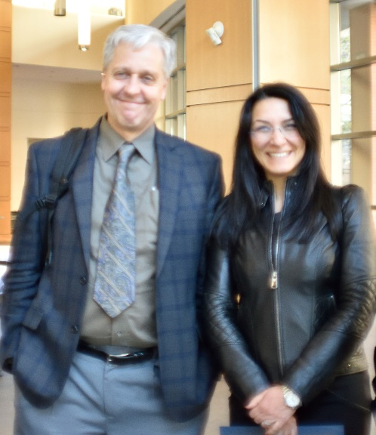
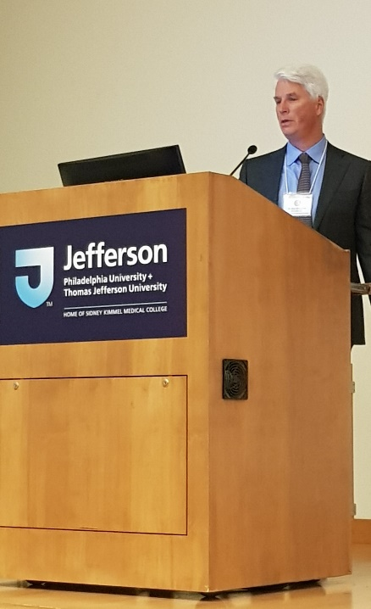
Figure 3 Dr. Altunary Agaoglu, LMHI Secretary General & Dr. Dan Cook, USA NVP
Figure 4 Dr. Ron Whitmont
On a more philosophical ground, It is well known that the Philadelphia homeopaths were followers of the teachings of Emmanuel Swedenborg, the Swedish scientist, philosopher, theologian, and mystic; yet, there is still very little documentation about the extent and depth of such influence on homeopathic philosophy, theory and practice. Professor John Haller presented homeopathy’s vitalist philosophical framework starting with Hahnemann and his spiritual inferences. Hahnemann considered the action of the medicines “spirit-like,” and this is, in fact, the main reason why homeopathy is rejected by most scientists.
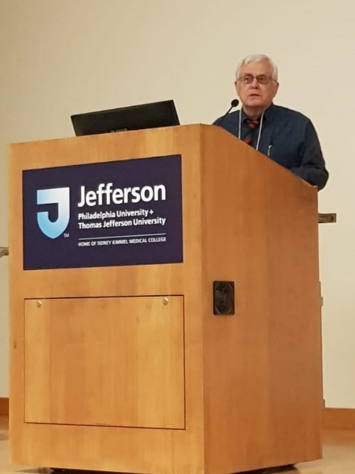
This vitalist paradigm declares that humans are not just made of material substance but also are conformed by spiritual -non-material- elements, that need to be taken into consideration in order to be able to truly heal disease. This can be exemplified by the fact that emotional disturbances, which are immaterial, can be the cause of, or a significant factor in, many types of organic disease.
Figure 5 Dr. John Haller
A concept possibly brought in from Swedenborgian ideology into homeopathy is Hering’s law of cure: from above-downward; from the inside-outward; from a more vital to less vital organ; and, in reverse order in which the symptoms appeared. It is also possible that Hering may have combined similar ideas coming from Hahnemann’s observations with those from Swedenborg.
Another Swedenborgian doctrine that influenced early homeopaths was the law of correspondences, according to which, everything that happens in the natural world has its counterpart in the spiritual world. Accordingly, there must be a perfect correspondence between the drug-disease and the patient’s spiritual condition.
James Garth Wilkinson, a British homeopath, also brought Swedenborgian concepts into homeopathy, such as the existence of a direct relationship between the higher homeopathic dynamizations, the result of successive dilutions and succussions, and the different levels of spirituality in humankind. The world arises as a gradual descent from the spiritual dimensions, through a series of degrees, into the visible and physical universe. Correspondingly, the homeopath recognizes disease as having a spiritual causation that manifests in a symptom-complex on the material body. The idea that high dynamizations are more appropriate for emotional and constitutional conditions comes from this theory. Though this is yet not confirmed by systematic analysis of treated cases.
Finally, James Tyler Kent wrote his Lectures in Homeopathic Philosophy which is mostly an exposition of Swedenborgian ideology as it applies to the practice of homeopathy. As an example, we find in Swedenborg, (Soul-Body, 14, XII), “By the human mind are meant its two faculties, which are called the understanding and the will. The understanding is the receptacle of the light of heaven, which in its essence is wisdom, and the will is the receptacle of the heat of heaven, which in its essence is love, …” For Kent, understanding and will are clearly presented as key to the successful homeopathic treatment.
It was this spiritual and immaterial framework, advocating the use of high potencies in homeopathic treatment, what conflicted with the low potency users, and framed a deep division within the homeopathic community, which has lived to the present.
Tying in the practice of the Philadelphia homeopathy masters with current practice, Dr. Galassi presented several cases treated by them, and by him and with detailed documentation, proving that those cases, treated homeopathically, due to their severity and the type of pathology, could not have been simple placebo responses. These cases were highly instructional and hope to see them widely published soon.
On a second lecture, professor Haller gave us a history of the homeopathic movement, particularly after the Flexner report, which was a serious injury to the homeopathic movement. He presented ample evidence that the lay homeopathic movement, particularly women, contributed significantly to the survival of homeopathy into the present. This resonates with and complements the point made by Dr. Whitmont, in his lecture at the event, on the importance of the consumers of homeopathy and the lay public in the battle to maintain homeopathy viable in the world.
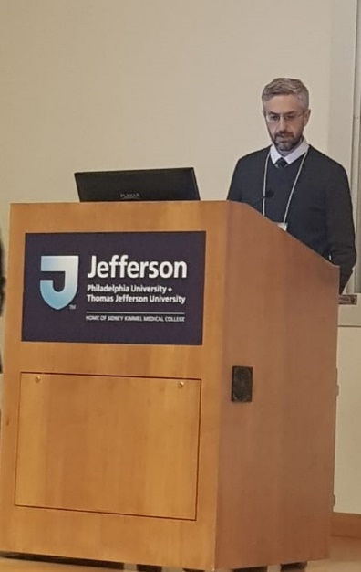
Dr. Alex Bekker, the editor of the American Journal of Homeopathic Medicine, and member of the AIH board of trustees, presented the history of post-graduate education in the United States, as it was provided by subsequent generations of homeopaths, trained by the early Philadelphia homeopaths, particularly the students of J.T.Kent. Pearls of wisdom from the writings of these luminaries from the homeopathic firmament adorned the presentation.
Figure 6 Dr. Alex Bekker

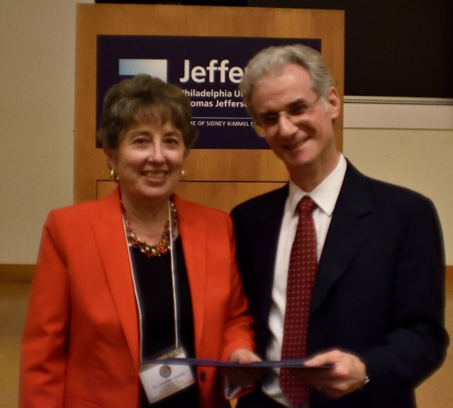
Figure 7 Dr. Jennifer Jacobs

The last lecture was presented by Dr. Jennifer Jacobs, one of the very few researchers who has had their work on homeopathy published in a conventional medical journal. Dr. Jacobs offered a comprehensive update of the current state of the evidence of homeopathy, including advances into discerning the current mechanism of action of homeopathic medicine. The data she presented brings us hope that the field may be close to a breakthrough in proving, conclusively, the nature of the homeopathic effect.
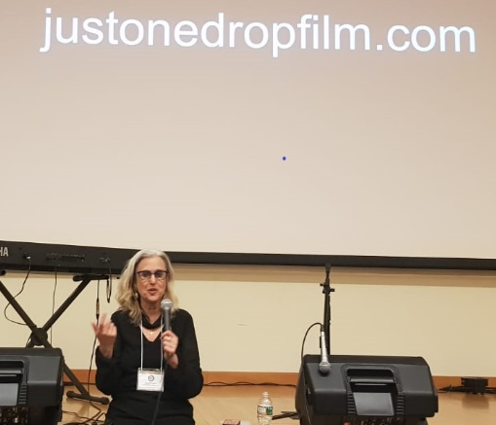
The “Just One Drop” documentary, directed and produced by Laurel Chiten, which included a newly added epilogue, updating the current situation with the request to the Australian Ombudsman to review and retract the seriously flawed and biased report by the Australian National Health and Medical Research Council (NHMRC); it also included an update of advances on research done under the auspices of the Homeopathic Research Institute. The projection was followed by a conversation and discussion with the film’s director.
Figure 8 Laurel Chiten, Director & Producer
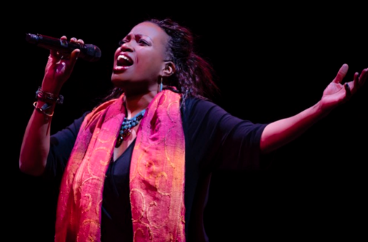
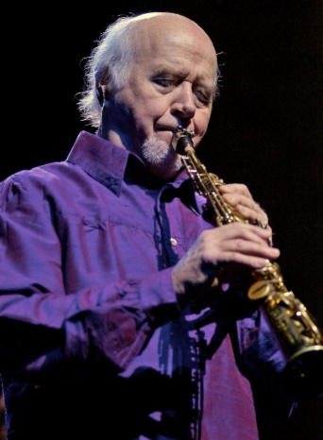
The celebration was crowned by an moving and inspired concert by the Paul Winter Trio, with Paul Winter on clarinet, Theresa Thomason on vocals & Jeff Holmes on Piano. The musicianship of these artists is extraordinary, and the event was very intimate and heartfelt. We wish more people could have listened to it.
Figure 9 Theresa Thomason
Figure 10 Paul Winter
The event was possible with the generosity of Hyland’s Inc, Boiron Laboratories, the Homeopathic Medical Association of the State of New York, the American Institute of Homeopathy, the Liga Medicorum Homeopathica Internationalis, and various other supporters and collaborators. We all thank the generosity of the presenters, who gave their time and knowledge to provide us with a truly memorable experience.
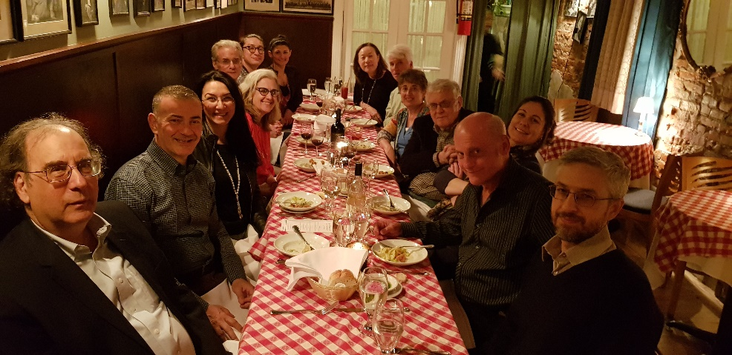
Figure 11 Speakers & Sponsor Dinner:(Clockwise from the bottom left): Dr. Dushkin; Dr. Galassi; Dr. Agaoglu; L. Chiten; Dr. Merizalde; G. Merizalde; M.Gorman; M. Merizalde Dr. Whitmont; Dr. Jacobs: Dr. Haller; M. Borneman; Dr. Cataldi; Dr. Bekker

